Portofolio 4

Gustav Helmet, Morten Street, Anders Wheelman & Sigrid Snapfield

2/26/2020

#Setup  
library(pacman)  
pacman::p_load("tidyverse", "lme4", "reshape2", "pracma","Hmisc")  
  
#Importing data  
alignment <- read.delim("alignment.txt", header = F, sep = "")  
  
#Importing the designmatrix  
fmrides<-as.matrix(read.csv("aud_fmri_design.csv", header=FALSE))  
##making it a time-series  
fmrides2<-ts(fmrides)

## 3. Realignment parameters

SPM produces a file with the realignment parameters, i.e. the calcultated participant movement and rotation per time point (called “rp. . . txt”, saved together with the functional data).

Import the realignment parameters into R.

### 3.a. Make a lineplot of the realignment parameters in R.

#Transforming the dataframe into a melted format  
alignment <- melt(alignment)

## No id variables; using all as measure variables

#Making a new time variable for the x-axis  
alignment$Time <- c(1:400)  
  
#Plotting   
ggplot(alignment, aes(Time, value, colour = variable))+  
 geom_line()+  
 ggtitle("Realignment parameters")

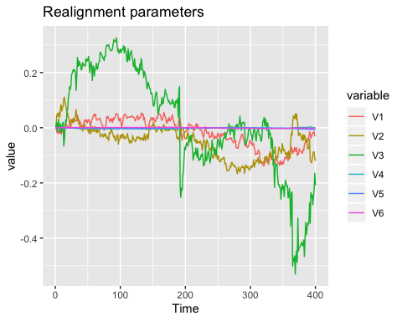

### 3.b. How far has the participant moved for each dimension during the experiment (Hint: use “apply()” to run a function across columns)?

#Converting all datapoints to absolute values and taking the sum of each parameter  
alignment %>% group_by(variable) %>% summarise(sum(sqrt(value^2)))

## # A tibble: 6 x 2  
## variable `sum(sqrt(value^2))`  
## <fct> <dbl>  
## 1 V1 17.5   
## 2 V2 23.8   
## 3 V3 62.6   
## 4 V4 0.953  
## 5 V5 0.574  
## 6 V6 0.485

### 3.c. Are any of the realignment parameters significantly correlated with the fMRI model (same model as used in exercise 3)?

#Transforming the data back from melted format and into a matrix  
alignment <- read.delim("alignment.txt", header = F, sep = "")  
alignment <- as.matrix(alignment)  
  
#Making the correlation test between all variables  
cor <- rcorr(alignment, fmrides, "spearman")  
  
#Extracting the relevant values  
cor <- data.frame("Rho_V1" = cor$r[1:6,7],  
 "p_value_V1" = cor$P[1:6,7],  
 "Significant_V1" = ifelse(cor$P[1:6,7]<0.05,"*"," "),  
 "Rho_V2" = cor$r[1:6,8],  
 "p_value_V2" = cor$P[1:6,8],  
 "Significant_V2" = ifelse(cor$P[1:6,8]<0.05,"*"," "))  
cor

## Rho_V1 p_value_V1 Significant_V1 Rho_V2 p_value_V2  
## V1 -0.041909199 0.4031953 -0.07888110 0.1152241  
## V2 0.043678605 0.3836154 0.01670629 0.7390563  
## V3 0.019339524 0.6997810 0.01297360 0.7958893  
## V4 -0.073960822 0.1397801 0.10019205 0.0452190  
## V5 0.088798454 0.0760769 0.03154922 0.5292401  
## V6 -0.005607653 0.9109797 -0.04839900 0.3342861  
## Significant_V2  
## V1   
## V2   
## V3   
## V4 *  
## V5   
## V6

Realignment parameter 4 (pitch) is significantly correlated with the second model covariate, which most likely is due to chance.

### Remove linear effects of time from the realignment parameters (hint: 1:400, fit a line and use residuals).

#Making a time vector  
time <- c(1:400)  
  
#Making a linear model  
m <- lm(alignment~time)  
  
#Encoding the residuals to matrix  
residuals <- m$residuals

### 3.d. Make a lineplot of the realignment parameters with time removed.

#Converting to new format  
melt_residuals <- melt(residuals)  
  
#Making the lineplot  
ggplot(melt_residuals, aes(Var1, value, colour = Var2))+  
 geom_line()+  
 labs(x = "Picture no.", y = "Value", title = "Realignment parameters with time removed")

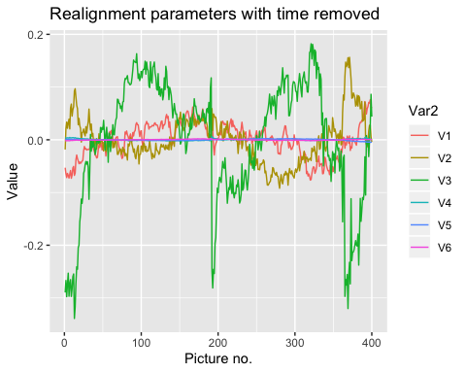

### 3.e. Make a lineplot including only the first realignment parameter before and after removal.

#Making a new data frame with the residuals and values of the first parameter.   
V1 <- data.frame("Time_corrected" = melt_residuals$value[melt_residuals$Var2 == "V1"],  
 "Not_time_corrected" = alignment[,1])  
  
#Transforming the data frame into a new format  
V1 <- melt(V1)

## No id variables; using all as measure variables

#Adding a variable for the x-axis  
V1$Picture_no <- c(1:400)  
  
#Plotting   
ggplot(V1, aes(Picture_no, value, colour = variable))+  
 geom_line()+  
 ggtitle("First realignment parameter")

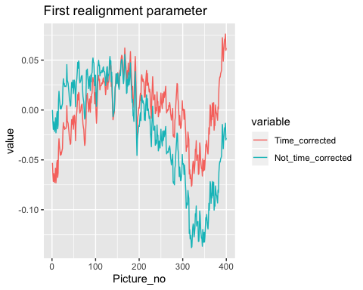

### 3.f. Are the realignment parameters (corrected for effects of time) now correlated with the fMRI model?

#Doing the correlation test like earlier  
res_cor <- rcorr(residuals, fmrides, "spearman")  
  
#Extracting the relevant correlation tests.   
res <- data.frame("Rho_V1" = res_cor$r[1:6,7],  
 "p_value_V1" = res_cor$P[1:6,7],  
 "Significant_V1" = ifelse(res_cor$P[1:6,7]<0.05,"*"," "),  
 "Rho_V2" = res_cor$r[1:6,8],  
 "p_value_V2" = res_cor$P[1:6,8],  
 "Significant_V2" = ifelse(res_cor$P[1:6,8]<0.05,"*"," "))  
  
res

## Rho_V1 p_value_V1 Significant_V1 Rho_V2 p_value_V2  
## V1 -0.0689742026 0.1685719 -0.192119821 0.0001104317  
## V2 0.0165235227 0.7418090 0.005468536 0.9131792812  
## V3 0.0006652631 0.9894175 -0.036721460 0.4639379782  
## V4 -0.0775218921 0.1216425 0.103419103 0.0386912359  
## V5 0.0831338250 0.0968444 0.030906097 0.5376735888  
## V6 -0.0291042628 0.5616540 -0.098282645 0.0495000355  
## Significant_V2  
## V1 *  
## V2   
## V3   
## V4 *  
## V5   
## V6 *

There are 3 significant relations between the second covariate and the parameters. They are probably due to change, but the first p value at 0.00011 seems very unlikely to get by chance, so maybe there is an actual correlation?